A high school club maintains information about its members in a MemberInfo object. A MemberInfo object stores a club member's name, year of graduation, and whether or not the club member is in good standing. A member who is in good standing has fulfilled all the responsibilities of club membership.

A partial declaration of the MemberInfo class is shown below.

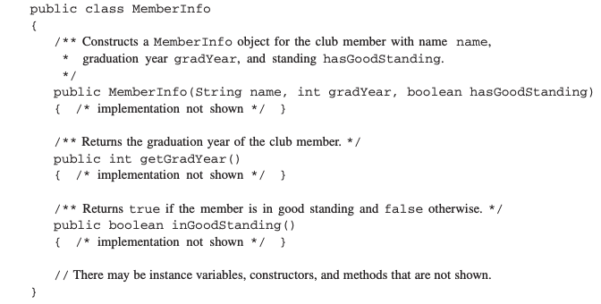

The ClubMembers class maintains a list of current club members. The declaration of the ClubMembers class is shown below.

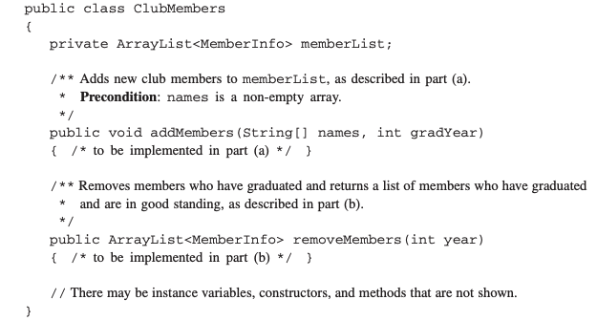

a) Write the ClubMembers method addMembers, which takes two parameters. The first parameter is a String array containing the names of new club members to be added. The second parameter is the graduation year of all the new club members. The method adds the new members to the memberList instance variable. The names can be added in any order. All members added are initially in good standing and share the same graduation year, gradYear.

b) Write the ClubMembers method removeMembers, which takes the following actions.

* Returns a list of all students who have graduated and are in good standing. A member has graduated if the member's graduation year is less than or equal to the method's year parameter. If no members meet these criteria, an empty list is returned.
* Removes from memberList all members who have graduated, regardless of whether or not they are in good standing.

The following example illustrates the results of a call to removeMembers.

The ArrayList memberList before the method call removeMembers(2018):

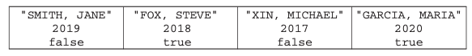

The ArrayList memberList after the method call removeMembers(2018):

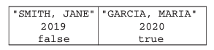

The ArrayList returned by the method call removeMembers (2018):

